Instructions
- Download resource.zip folder and unzip
- Open the unzipped folder via VS Code
- In the terminal, go to the folder and run the following command to launch the Node server:

node server.js
- In the browser, enter the following URLs to work on each question:
  - Question 1: http://localhost:3000/register.html
  - Question 2: http://localhost:3000/student.html

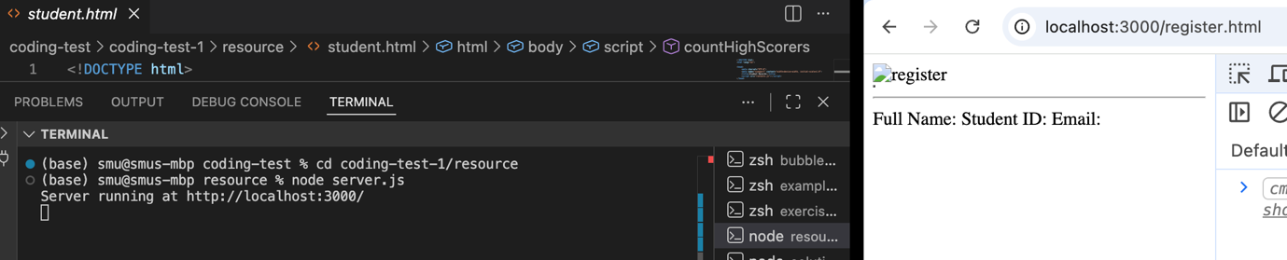

Question 1: Student Course Registration Page
You are required to create a HTML page named register.html for a university course registration system.

Part A: Page Structure [1 mark]
Your HTML document must:
- Set the page title to “Course Registration”
- Include a main heading (<h1>) with the text: Course Registration Form
- Below the heading, include the image “register.jpeg” given in “img” folder.


Part B: Registration Form [3 marks]
Below the image “register.jpeg”, create a course registration form.

Form requirements:
- The form must use “method” and “action” attributes
- Create a course table at the beginning of the form. Table requirements are as follows:
  - Use <table>, <thead>, <tbody>, <tr>, <th>, and <td>
  - The table must have 3 columns:
    - Course Code
    - Course Name
    - Register?
  - The table must contain at least 3 courses
  - The table cells must have border lines
  - Table cells correspond to the “Register?” column are checkboxes.
    - These checkboxes should have the “name” attribute with the value of “courses”
    - They should also have “value” attributes with proper values. For example, the checkbox corresponds to the course “IS113” should have the “value” attribute with the value “is113”.
Note: Course Code and Course Name can be arbitrary.
See below for an example
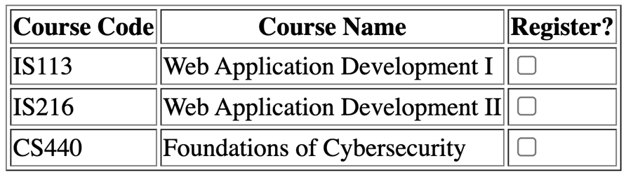
- Below the table, the form must include the following input fields
Label Text | Input Type
Full Name | text
Student ID | number
Email Address | email
- Lastly, the form must include the following a submit button with the text “Register”
  - When the user clicks this submit button, the form must send a GET request to “/register”

The expected output is the following:
(a) When you visit the page for the first time   | (b) You enter some information and click “Register” button  
(c) the URL and the web page should look something like this after clicking the “Register” button:

Question 2: Student Data Analyzer
In student.html, you are given an array of strings, called records, where each string represents a student record in the following format: "studentId|fullName|programme|score"
const records = [
"8001|Alice Tan|IS|85",
"8002|Bob Lim|CS|72",
"8003|Charlie Ng|SE|90",
"8004|Diana Lee|CS|88",
"8005|Ethan Ong|IS|85",
"8006|Ferdian Lee|IS|86"
];

Note: you can click on the “Run Tests” button to test whether your function implementations satisfy the given requirements.

Part A — Parse Records [1 mark]
Complete the given function: parseRecords(records)
Given records, which is an array of strings described above, it must return an array of objects (students) in the following format:
[
{ studentId: "8001", fullName: "Alice Tan", programme: "IS", score: 85 },
...
]

Part B — Filter and Count [1 mark]
Complete the given function:
countHighScorers(students, programme, threshold)
It must:
- Count how many students are in the given programme
- Only include students whose score is greater than or equal to threshold
For example,
let students = parseRecords(records)
countHighScorers(students, "IS", 85); // returns 3

Part C — Programme Statistics [1 mark]
Complete the given function:
programmeStats(students)
It must return an object showing, for each programme:
- Total number of students
- Average score in 2 decimal places (explore: JavaScript built-in toFixed method)
For example,
{
IS: { count: 3, average: 85.33 },
CS: { count: 2, average: 80.00 },
…
}

